Chapter 8: Forces, energy and motion

Name: ________________________________ Date: _____________________________

 | Inertia is:  - a force that resists motion.  - a tendency to resist motion.  - a force that changes motion.  - a tendency to change motion. | B | 1
 | The crumple zone of a car is designed to:  - allow the vehicle and passengers to stop more slowly.  - decrease the time before the car comes to a stop after a collision.  - allow the chassis to bend.  - create a reaction force that equals the action force. | A | 1
 | A car manufacturer wants to produce cars that accelerate faster. Which changes in their cars would result in greater acceleration?  - Increase both the forward force by the engine and the mass of the car.  - Decrease both the forward force and the mass of the car.  - Increase the forward force and decrease the mass of the car.  - Decrease the forward force and increase the mass of the car. | C | 1
 | Select the correct answer about a rocket engine.  - The exhaust gases produce a thrust that pushes the rocket upwards.  - The oxygen used to burn the rocket fuel comes from the atmosphere.  - A rocket takes off because the reaction force of the ground on the rocket overcomes the weight of the rocket.  - Rocket engines are identical to jet engines in aircraft. | A | 1
 | Velocity is a measure of the rate:  - at which distance is covered.  - at which speed increases.  - of change in position.  - of change in acceleration. | C | 1
 | A car is driven along a highway at an average speed of 90 km/h for 2 hours without a rest stop. What distance has it covered?  - 45 km  - 180 km  - 360 km  - Not enough information is given to calculate | B | 1
 | A loaded semi-trailer travels from Melbourne to Bendigo, a distance of 150 km, in 3 hours. It unloads and returns to Melbourne in 2 hours. Without including the time taken to unload, the average speed for the whole journey there and  back is:  - zero.  - 50 km/h.  - 60 km/h.  - 62.5 km/h. | C | 1
 | Which of the following speed-detection devices measure instantaneous speed?  - Laser guns  - Radar guns  - Digitectors  - Ticker timers | B | 1
 | Acceleration is best described as the rate of change in:  - energy transfer.  - net force.  - position.  - speed. | D | 1
 | Which of the following are descriptions of work being done on an object by a person?  - A gardener pushes a lawnmower.  - A student thinks about the answer to a test question.  - A diver falls through the air.  - A weightlifter holds a heavy barbell motionless above her head. | A | 1
 | Which of the following quantities is measured in joules?  - Force  - Energy  - Speed  - Weight | B | 1
 | Which of the following best describes the Law of Conservation of Energy?  - Energy can be created but it can never be destroyed.  - Energy can be destroyed but it can never be created.  - Energy can never be created or destroyed.  - Energy can be created and destroyed. | C | 1
 | A car travelling at 60 km/h increases its speed to 100 km/h in 8 seconds. Its average acceleration is:  - 5 km/h/s.  - 8 km/h/s.  - 40 km/h/s.  - 60 km/h/s. | A | 1
 | The weight of a 50 kg student on Earth is closest to:  - 9.8 N/kg.  - 50 kg.  - 50 N.  - 500 N. | D | 1
 | Which of the following statements are correct?  - A car at rest has at least two forces acting on it.  - A car at rest has no forces acting on it.  - When you take your foot off the car’s accelerator, the car slows down because there are no more forces acting on it.  - When you brake in a car that is rolling down a hill, the car stops because all of the forces add up to zero. | A | 1
 | Which law is expressed as follows?  The size of an object’s acceleration depends directly on the size of the net unbalancing force acting on it and is inversely proportional to its mass.  - Newton’s first law  - Newton’s second law  - Newton’s third law  - Galileo’s law of inertia | B | 1
 | The following drawing shows a triangular walking track. The track PQ is oriented north-south.  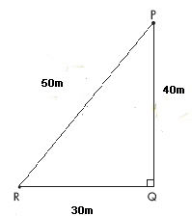  A walker starts at P and walks clockwise around the track. She makes five full circuits and then walks back to R along the PR path.  Select the correct statement.  - The final displacement of the walker is 50 m in a direction west of south.  - The total distance walked is 50 m.  - The total displacement of the walker is 650 m.  - The total distance walked is 600 m. | A | 1
 | Why is the family car packed with luggage and people for a holiday more likely to hit the truck in front if the truck brakes suddenly?  - The driver is more easily distracted.  - The reaction force of the car is reduced.  - The car has a greater mass so decelerates more slowly than usual.  - The inertia of the people prevents the brakes from having any effect. | C | 1
 | A student walks a distance of 1.2 km to school in a time of 15 minutes. Which of the following statements are certain to be correct?  - Her average speed is 4.8 km/h.  - Her average velocity is 4.8 km/h.  - Her instantaneous speed is 4.8 km/h.  - Her instantaneous velocity is 4.8 km/h. | A | 1
 | A car travelling at 60 km/h increases its speed to 100 km/h in 8 seconds. Its average acceleration is:  - 5 km/h/s.  - 8 km/h/s.  - 40 km/h/s.  - 60 km/h/s. | A | 1
 | A ticker timer is used in the laboratory to investigate motion. The time interval between two dots on the ticker tape is:  - 0.1 second.  - 0.2 second.  - 0.01 second.  - 0.02 second. | D | 1
 | AFL coaches and sports scientists use GPS locators strapped to the upper backs of football players to:  - analyse the player’s movements to improve performance.  - calculate the force with which they kick the ball.  - determine their exact location on the field.  - instantly calculate their momentum throughout the match. | A | 1
 | A class is studying Newton’s three laws.  The teacher asks a student wearing rollerblades to face the wall and push against it. She moves backwards away from the wall. Which is the best explanation for her movement?  - Her action of pushing resulted in a reaction force by the wall, in the opposite direction to her push.  - She used her feet to push herself away from the wall.  - The push is a force and causes her to accelerate.  - The inertia of the student is responsible for her acceleration. | A | 1
 | - What is thrust?  - How is it used in a jet? | - The forward push of the exhaust gases from a jet engine is called the thrust.  - When the thrust is very large it is able to push the jet forward. | 2
 | Explain why it is dangerous to have large parcels or sharp objects loose in the back of a moving car. | When the car stops, the objects will still keep moving due to inertia, and may hit and injure someone. | 2
 | Describe how a front air bag protects the driver of a car that has stopped suddenly as a result of a collision. | It stops or slows the upper body down before it collides with the steering wheel, dashboard or windscreen. | 2
 | - Describe how head restraints protect the occupants of a stationary car that is struck from behind by another vehicle.  - What happens to an occupant in this type of collision if there are no head restraints? | - Head restraints push the head forwards with the rest of the body, which is pushed forwards by the back of the seat.  - Without them, the head would be left behind, causing neck strain and spinal injuries. | 2
 | Why are cars deliberately designed to crumple in the front and rear? | They absorb and spread energy transferred to the car during a collision. It allows the car to stop more gradually, reducing the risk of death or serious injury to occupants. | 2
 | - What equipment would you need to measure the speed of a toy car?  - How would your measurements change, if the batteries were flat and the car moved more slowly? | - Stopwatch, metre ruler  - Longer times to cover the same distance | 2
 | How long would it take a student to walk a distance of 2 km at an average speed of  5 km/h? Show all calculations. | 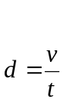  Therefore,  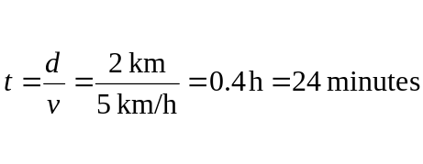 | 2
 | Calculate the acceleration of a 5 kg toy car if it is pushed along a floor so that the total force acting on it is 30 N. Show all your calculations. | 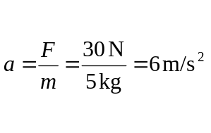 | 2
 | The graph below compares the performance of five identical cars as they accelerate from a standing start to a speed of 60 km/h.  - Which of the cars has the greatest acceleration?  - Which of the cars has the least net force applied?  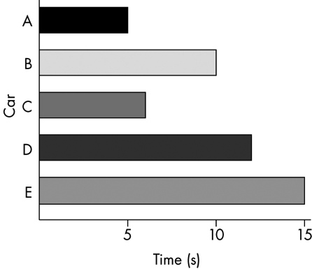 | - A  - E | 3
 | Describe the motion of a ball placed on the middle of the back seat of a car in the following situations.  - The car brakes suddenly.  - The car turns right.  - The car accelerates. | - The ball rolls forward off the seat.  - The ball rolls across the seat to the left.  - The ball moves to the back of the seat. | 3
 | John blows up a balloon and releases it. Predict and explain how the balloon will move. | The balloon will move in the opposite direction to the balloon opening when released.  The balloon has been stretched, and as it contracts, it pushes the air out of the opening. According to Newton’s third law, the air will push back on the balloon in the opposite direction. | 3
 | A snail completes one lap around a circular track, a distance of 2.7 metres, in a time of 3 minutes. Calculate the following, showing all working. The snail’s:  - average speed (in cm/s)  - average velocity (in m/s) | 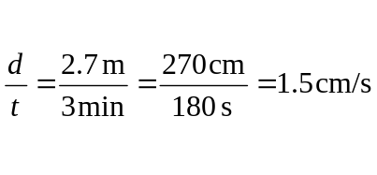  - Zero | 4
 | A car trip from Melbourne to Sydney — a distance of 900 km — takes 10 hours. Calculate the average speed of the car (show all working) in:  - km/h  - m/s. | 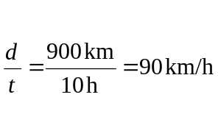  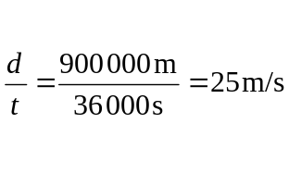 | 4
 | The diagram below shows a small section  of ticker tape used to record the motion of  a student pulling the tape through a ticker timer. The marked interval represents a time interval of 0.1 seconds.  - What is the average speed (in cm/s) shown during the marked interval?  - Is the speed throughout the marked interval constant, increasing or decreasing?  - How often does this ticker timer produce a new dot?  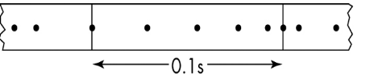 | - 31 cm/s  - Decreasing  - Every 0.02 s or every fiftieth of a second | 3
 | A car stopped at traffic lights increases its speed by an average of 4 m/s each second during the first five seconds after the light turns green.  - What is the average acceleration of the car?  - Calculate the speed of the car (in m/s) after five seconds.  - Is the car breaking the 60 km/h speed limit after five seconds? Show any calculations necessary to make a decision. | - 4 m/s/s  - 20 m/s  - Yes. 20 m/s = 72 km/h. (Some evidence of conversion should be shown to get two marks for part (c).) | 4
 | An athlete runs a 100-metre race in a ten-second interval. The instantaneous speed of the athlete changes throughout the race.  - What is instantaneous speed?  - What is the average speed of the athlete?  - Describe how the instantaneous speed of the athlete might change during the ten-second interval. | - Instantaneous speed is the speed at a particular instant of time.  - 10 m/s  - Answer must indicate that instantaneous speed is lower than average speed at some stages during the race (e.g. in the early stages) and higher than average speed at others (e.g. the middle of the race). | 4
 | The diagram below shows part of a ticker tape used to record the motion of a toy car as it moves along a table. Each marked interval represents a time interval of 0.2 seconds.  During which one or more of the four time intervals P, Q, R and S was the acceleration of the car:  - zero  - positive  - negative  - constant?  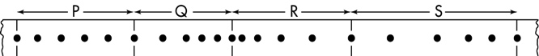 | - P  - R  - Q, S  - R | 5
 | A hungry tortoise walks 5 metres to the east to reach a juicy plant. The tortoise, a fussy eater, then sees a much juicier plant 5 metres to the north. Without stopping, the tortoise sprints to the second plant. The whole journey takes the tortoise three minutes.  - How far is the tortoise from its original position?  - What is the average speed of the tortoise in m/s?  - What is the average velocity of the tortoise in m/s?  Show all working. Round off answers correctly to two decimal places.  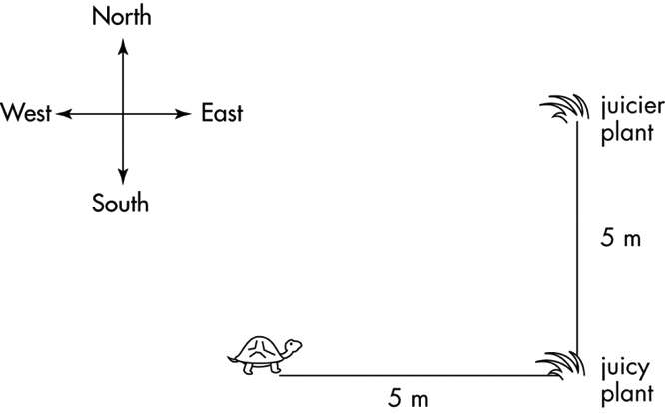 | - 7.07 m (using Pythagoras’ Theorem or scale diagram).  - 10 m/180 s = 0.06 m/s  - 7.07 m/180 s = 0.04 m/s north-east | 7
 | A bungee jumper with a weight of 600 newtons falls through a distance of 50 metres and stops just before reaching the cold surface of a river.  - How much work is done on the bungee jumper by the force of gravity?  - How much of the bungee jumper’s initial gravitational potential energy is converted into other forms as a result of the fall?  - Lists three other forms of energy to which most of the bungee jumper’s lost gravitational potential energy is converted during the fall. | - 30 000 J  - 30 000 J  - Kinetic energy, elastic potential energy, heat energy | 5

